PROJECT REPORT TEMPLATE

1. INTRODUCTION

1.1 OVERVIEW

The general concept of a metropolitan area is that of a core area containing a large population nucleus, together with adjacent communities that have a high degree of economic and social integration with that core.

1.2 PURPPOSE

House price prediction in a metropolitan city in India is a valuable solution for potential home buyers, real estate agents, and investors.

2. PROBLEM DEFINITION & DESIGH THINKING

2.1 EMPATHY MAP

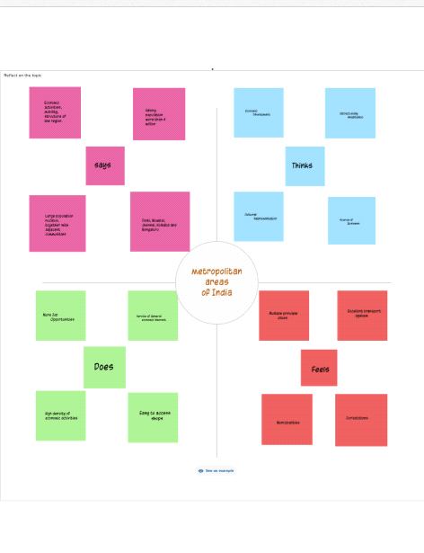

2.2 IDEATION & BRAINSTROMING MAP

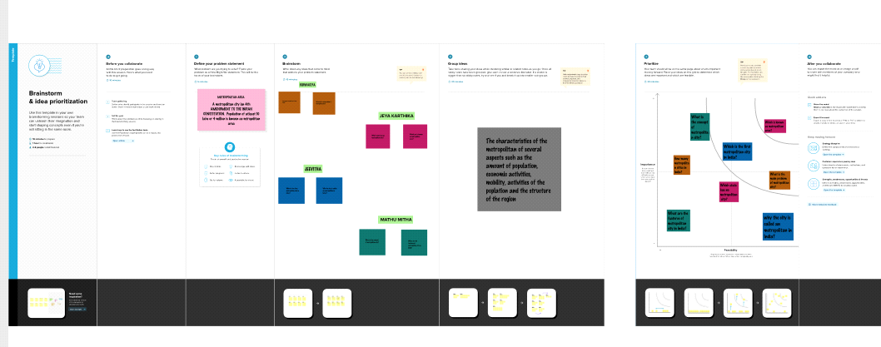

3. RESULT

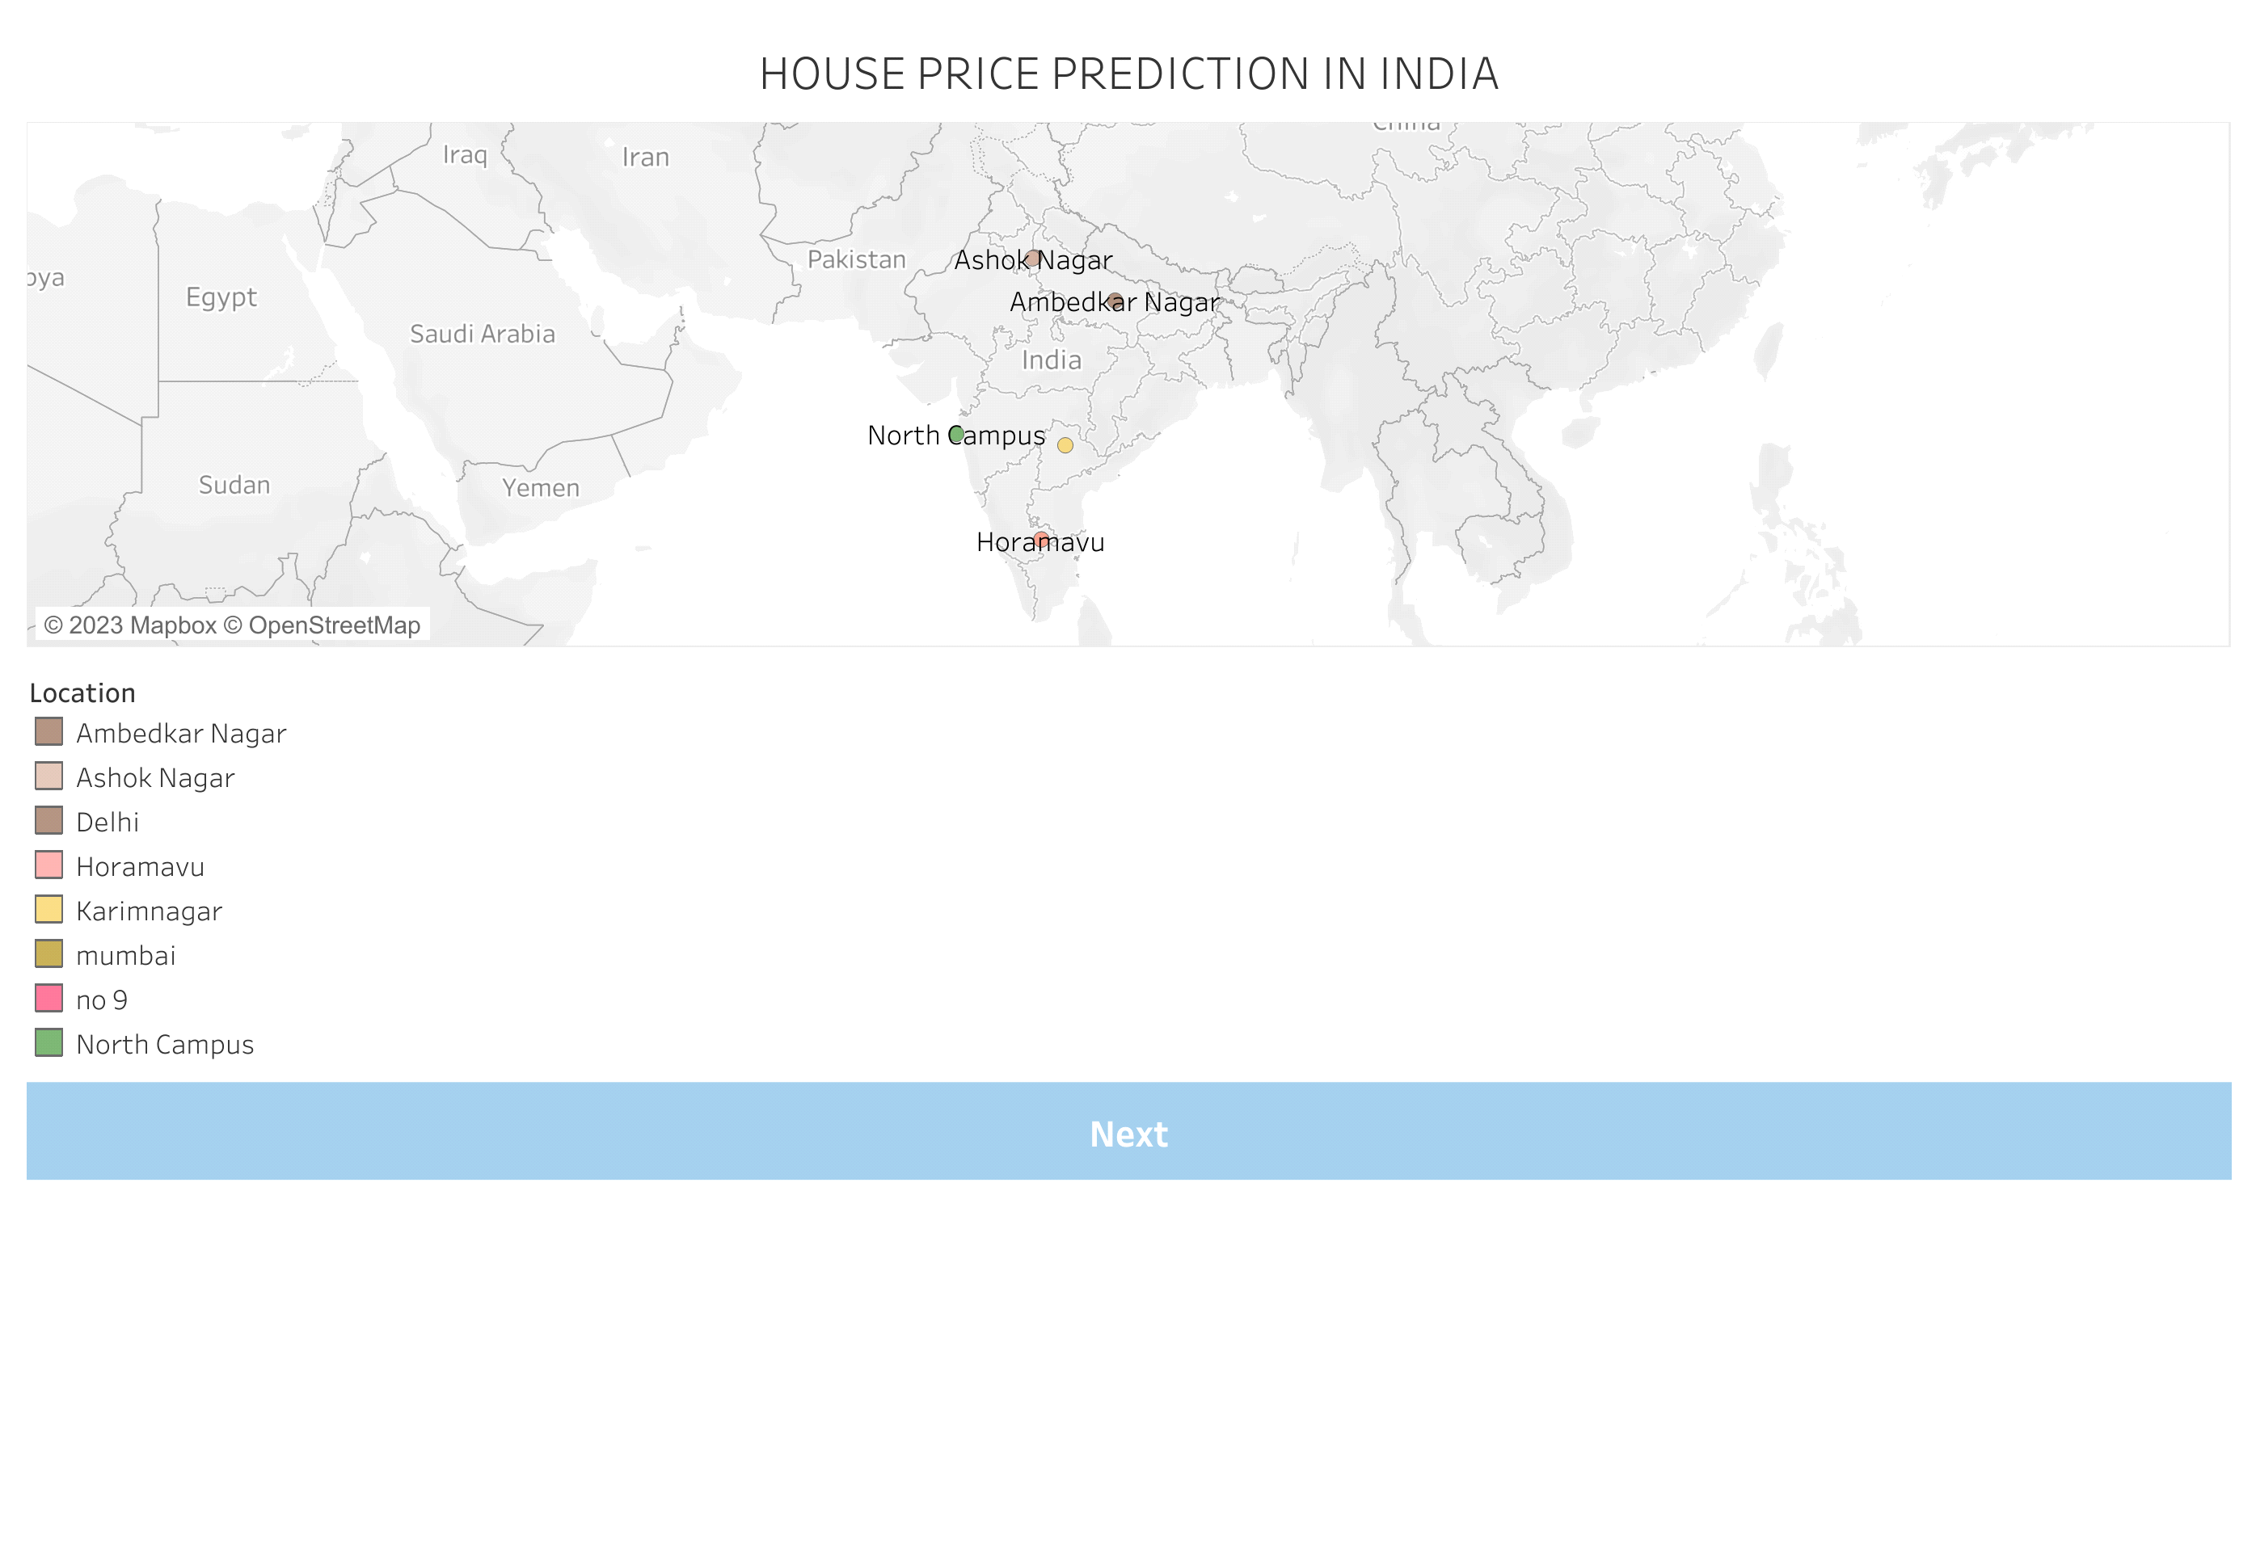

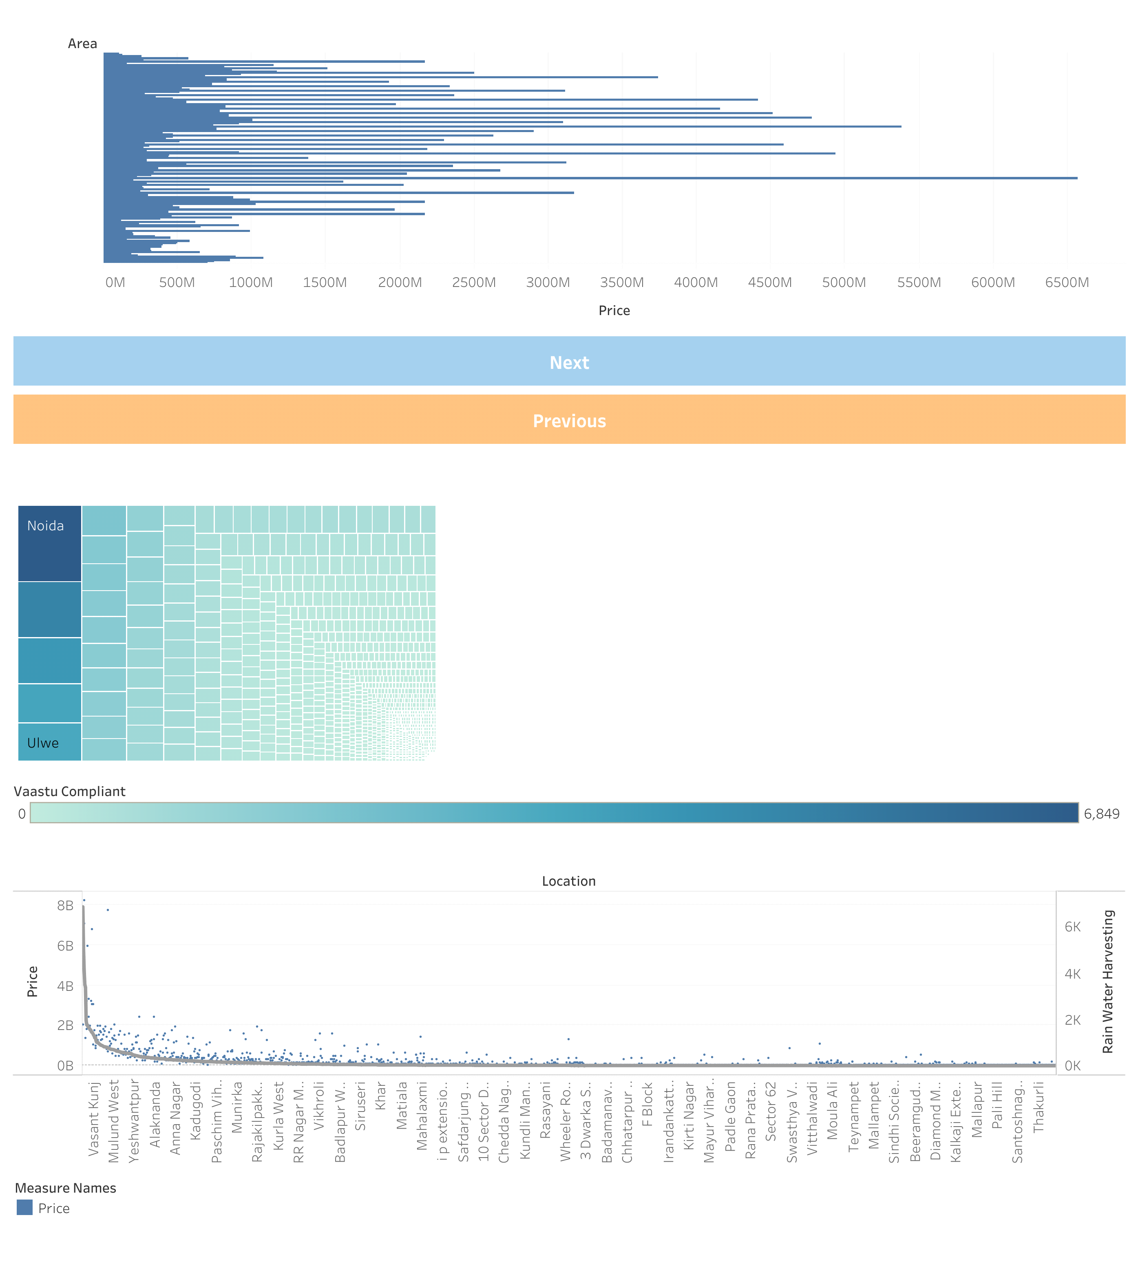

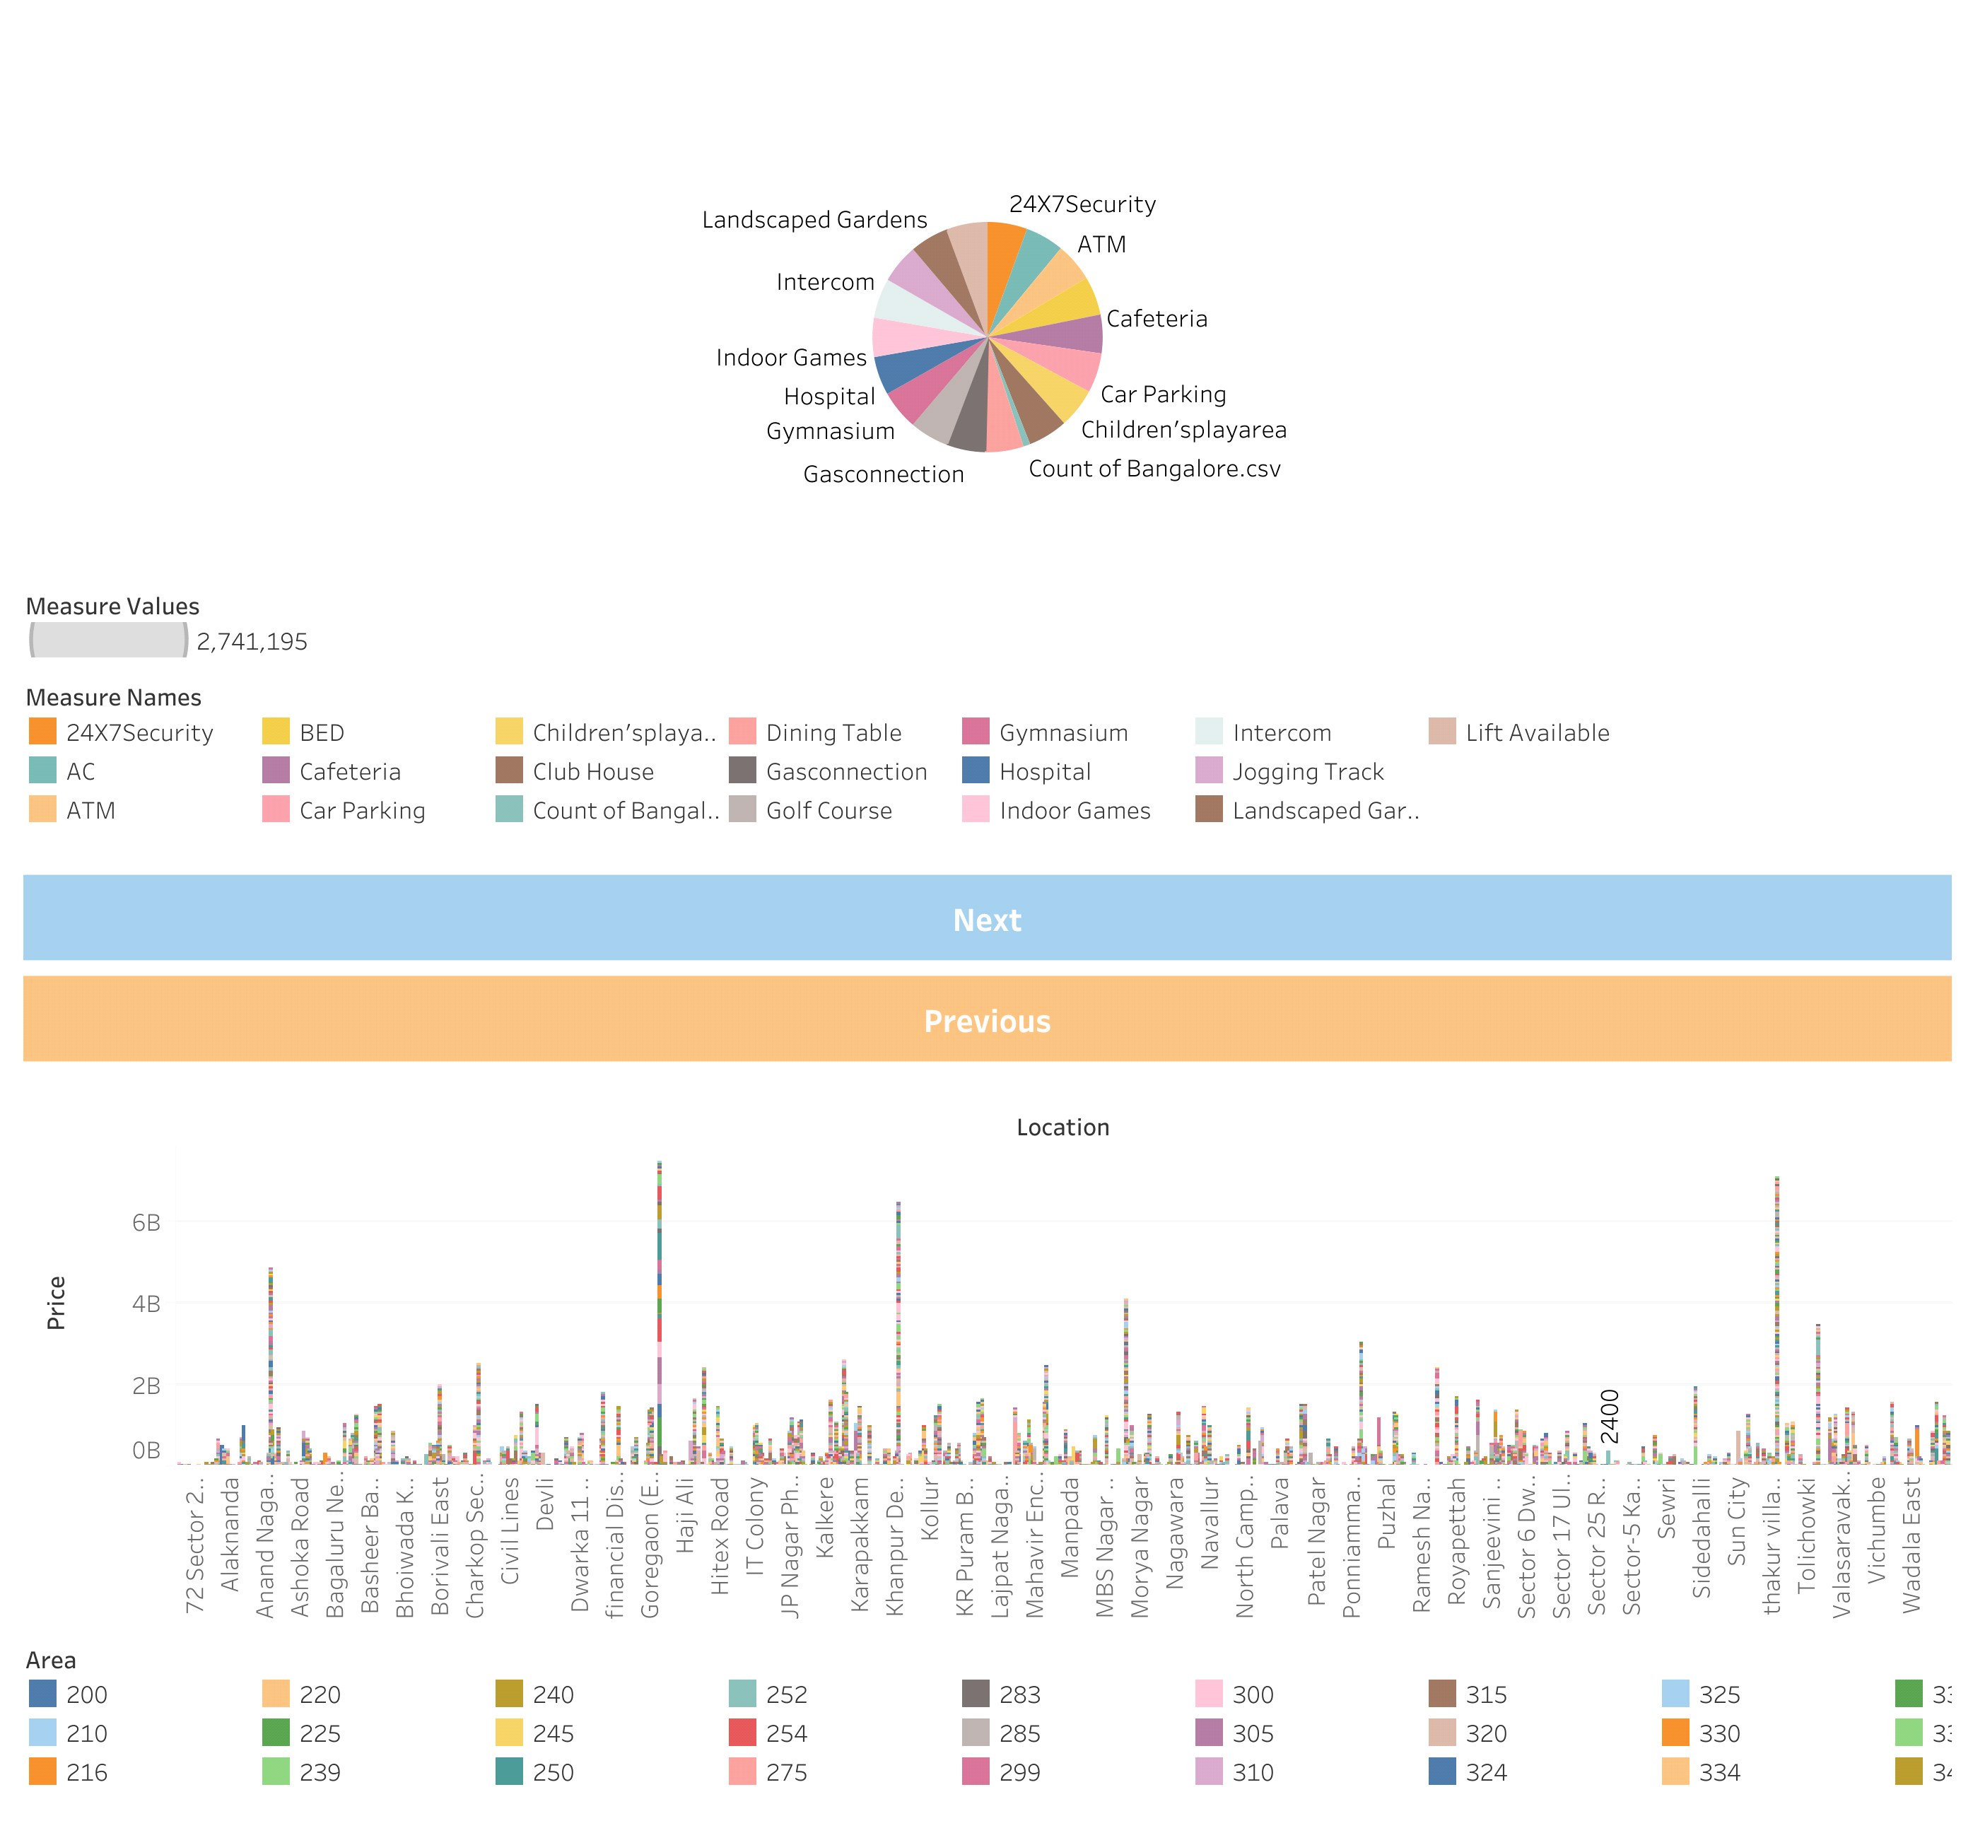

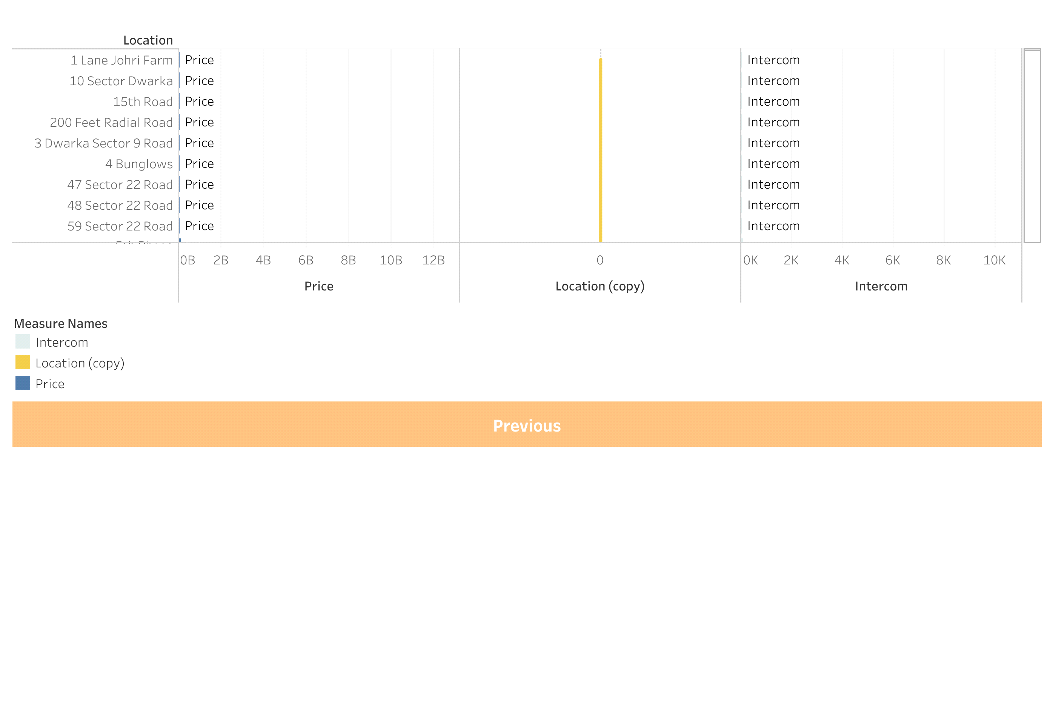

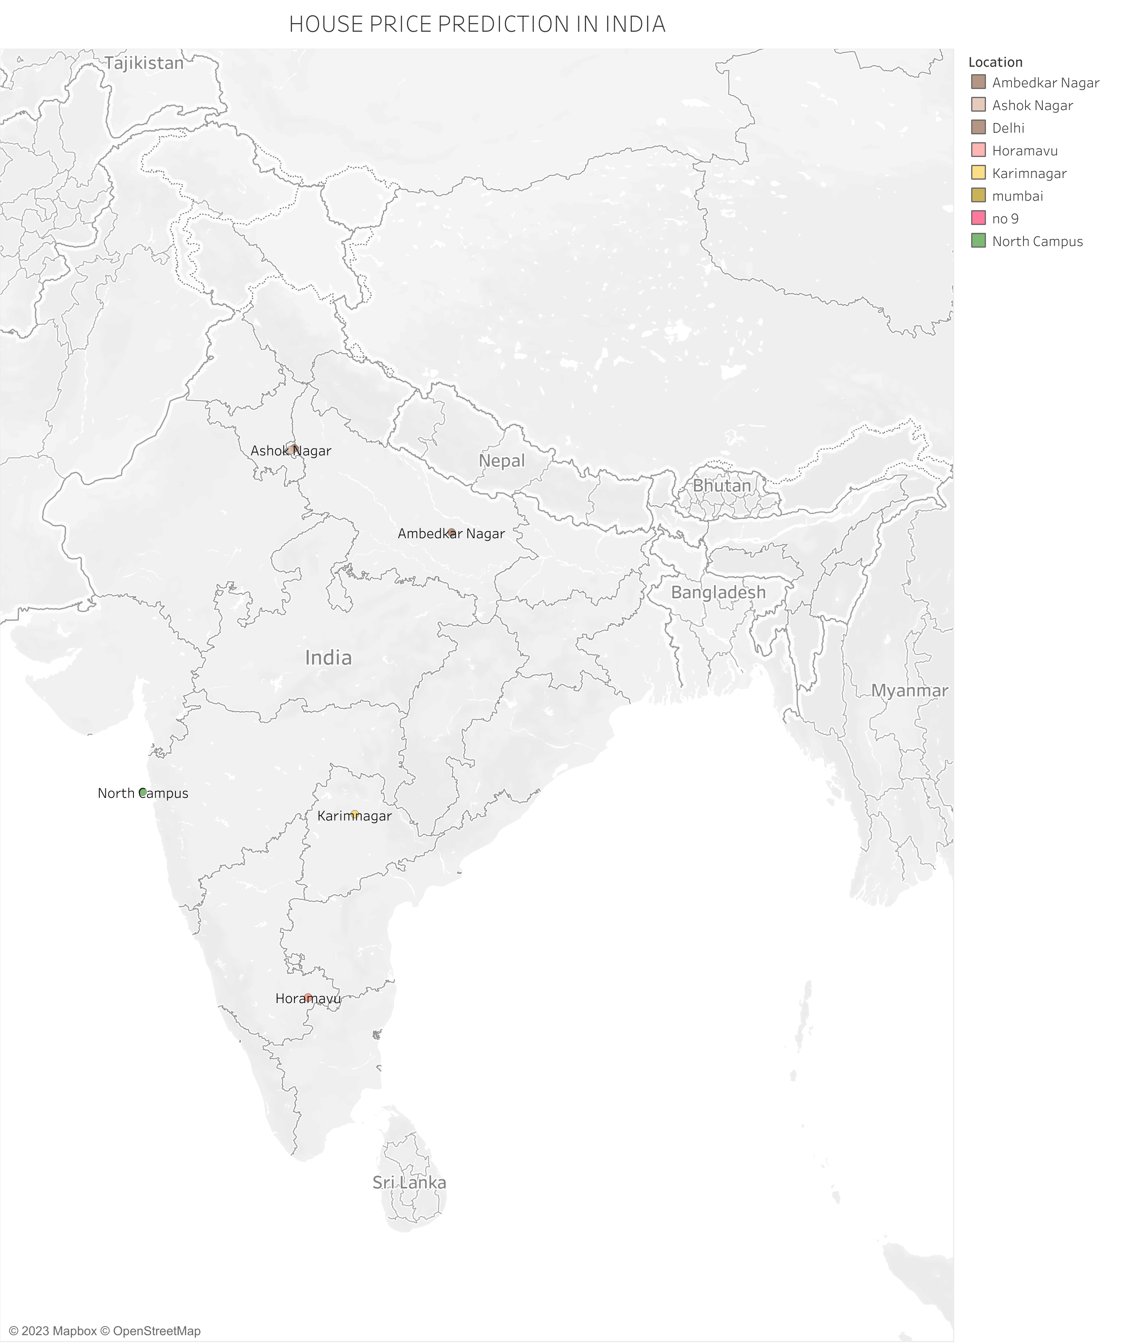

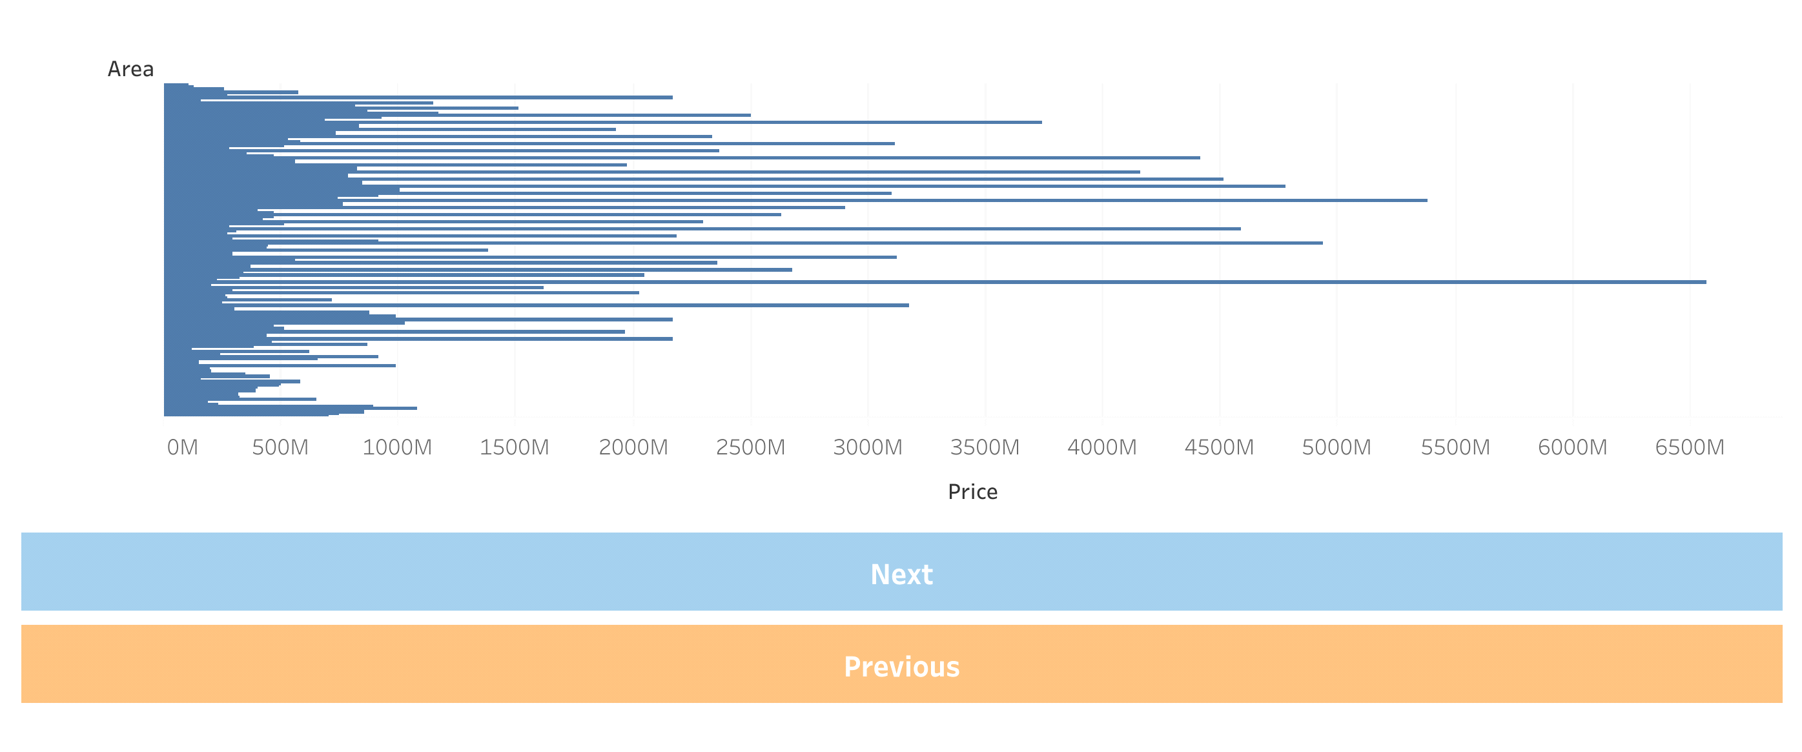

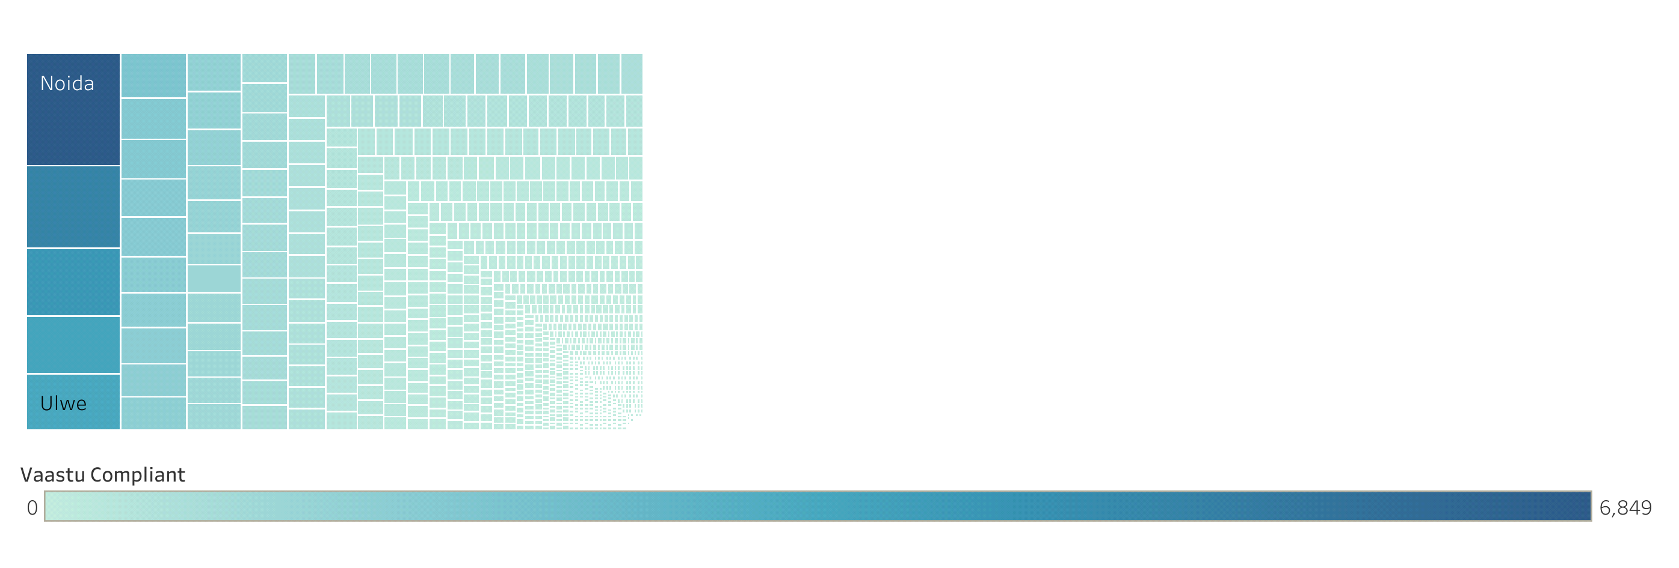

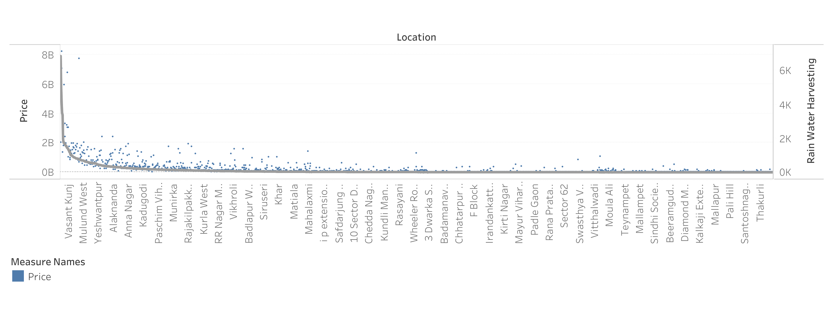

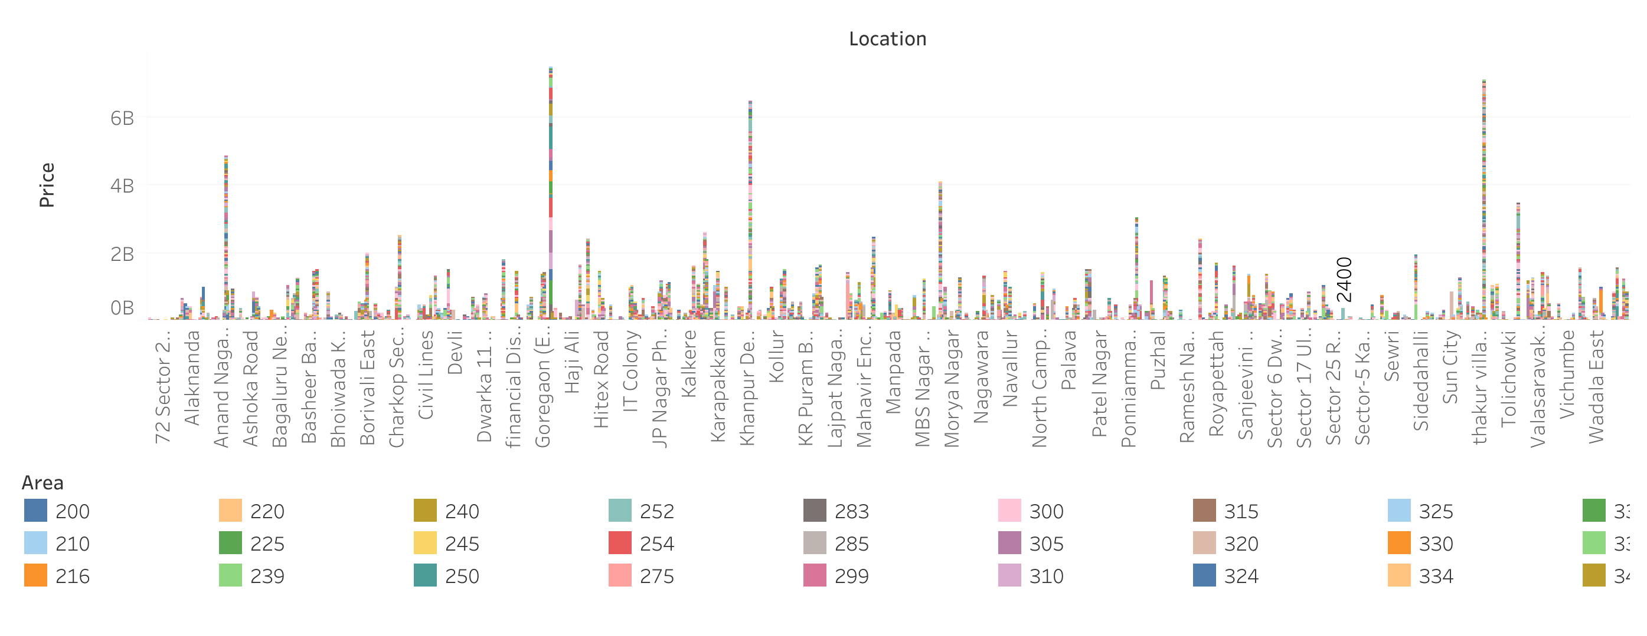

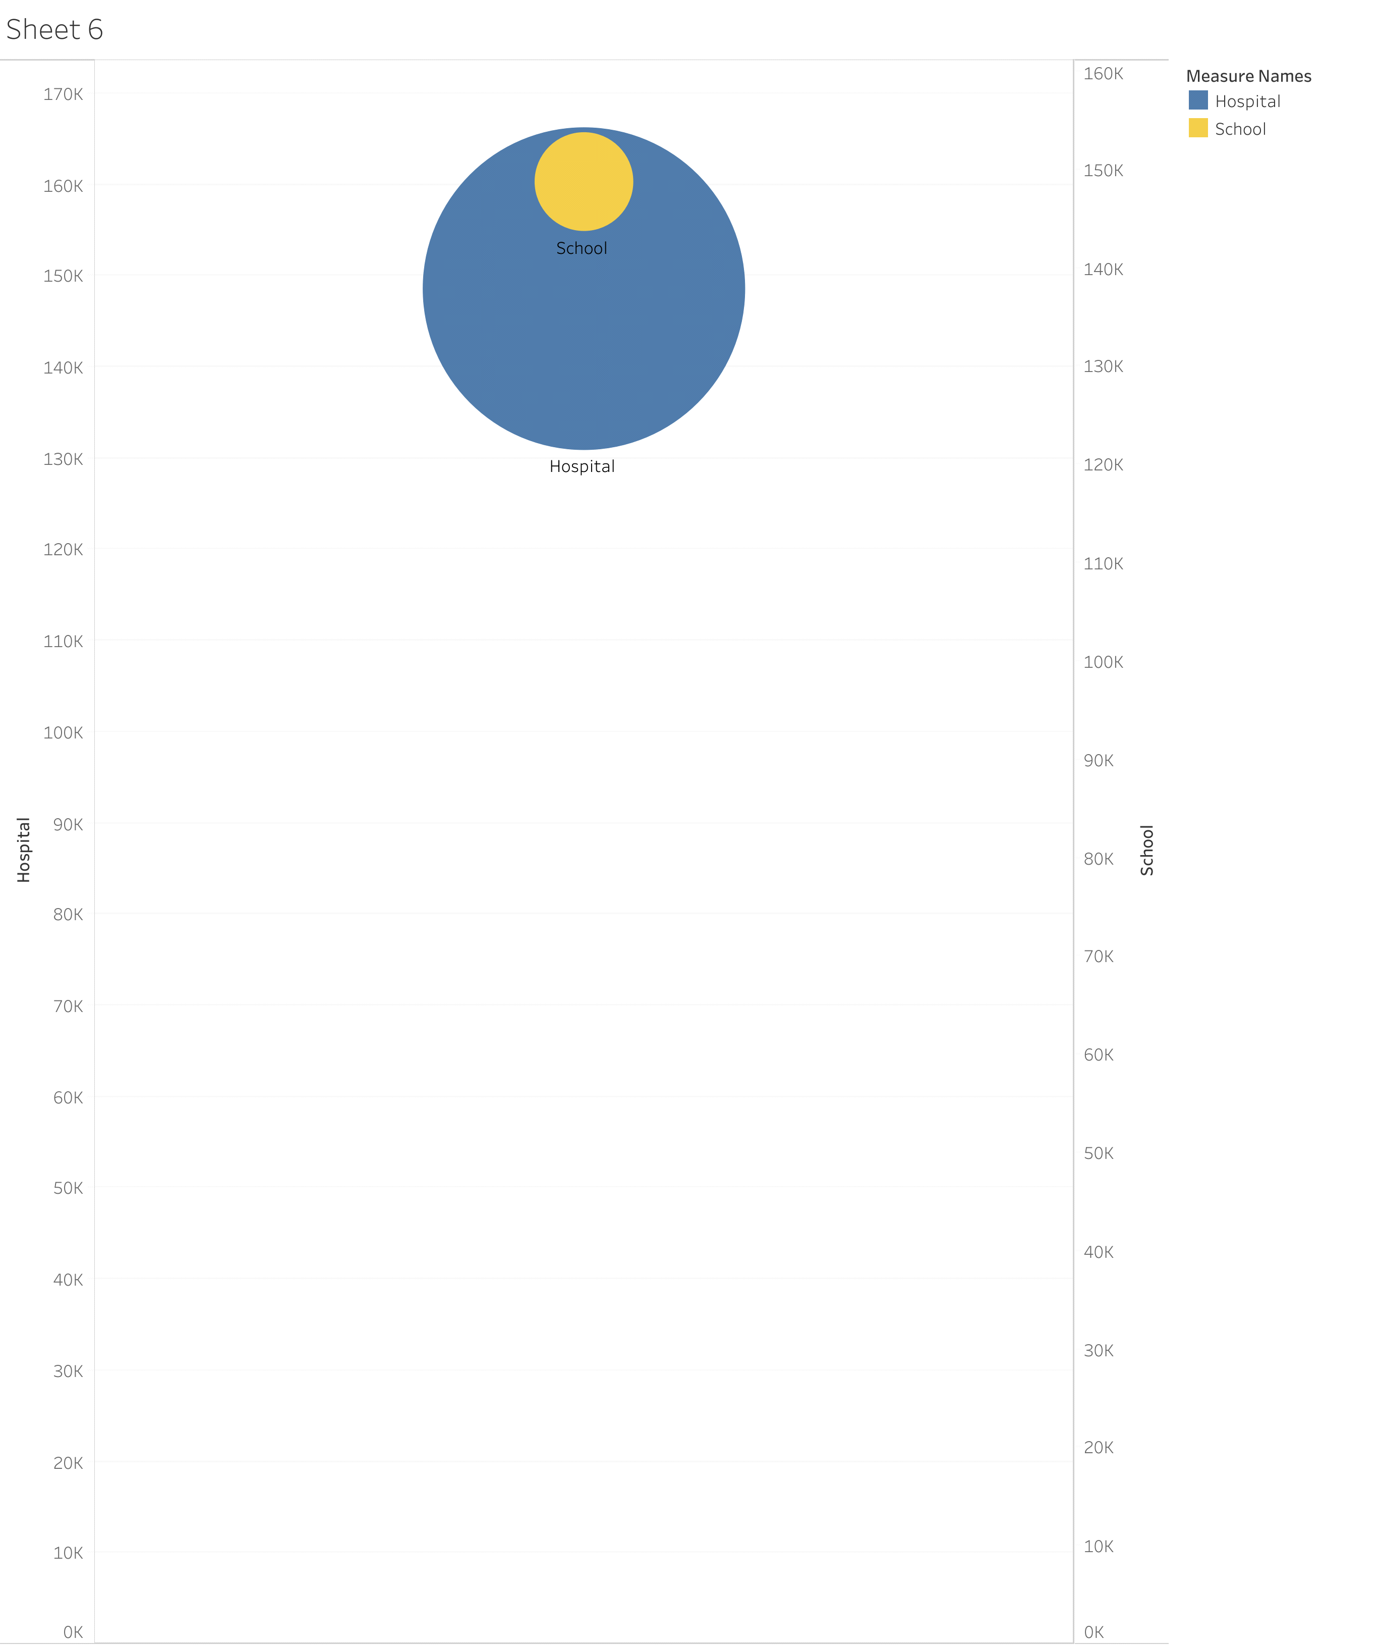

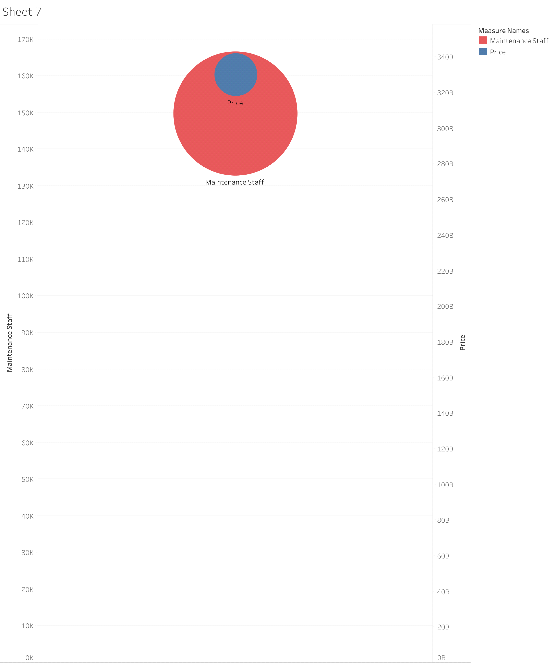



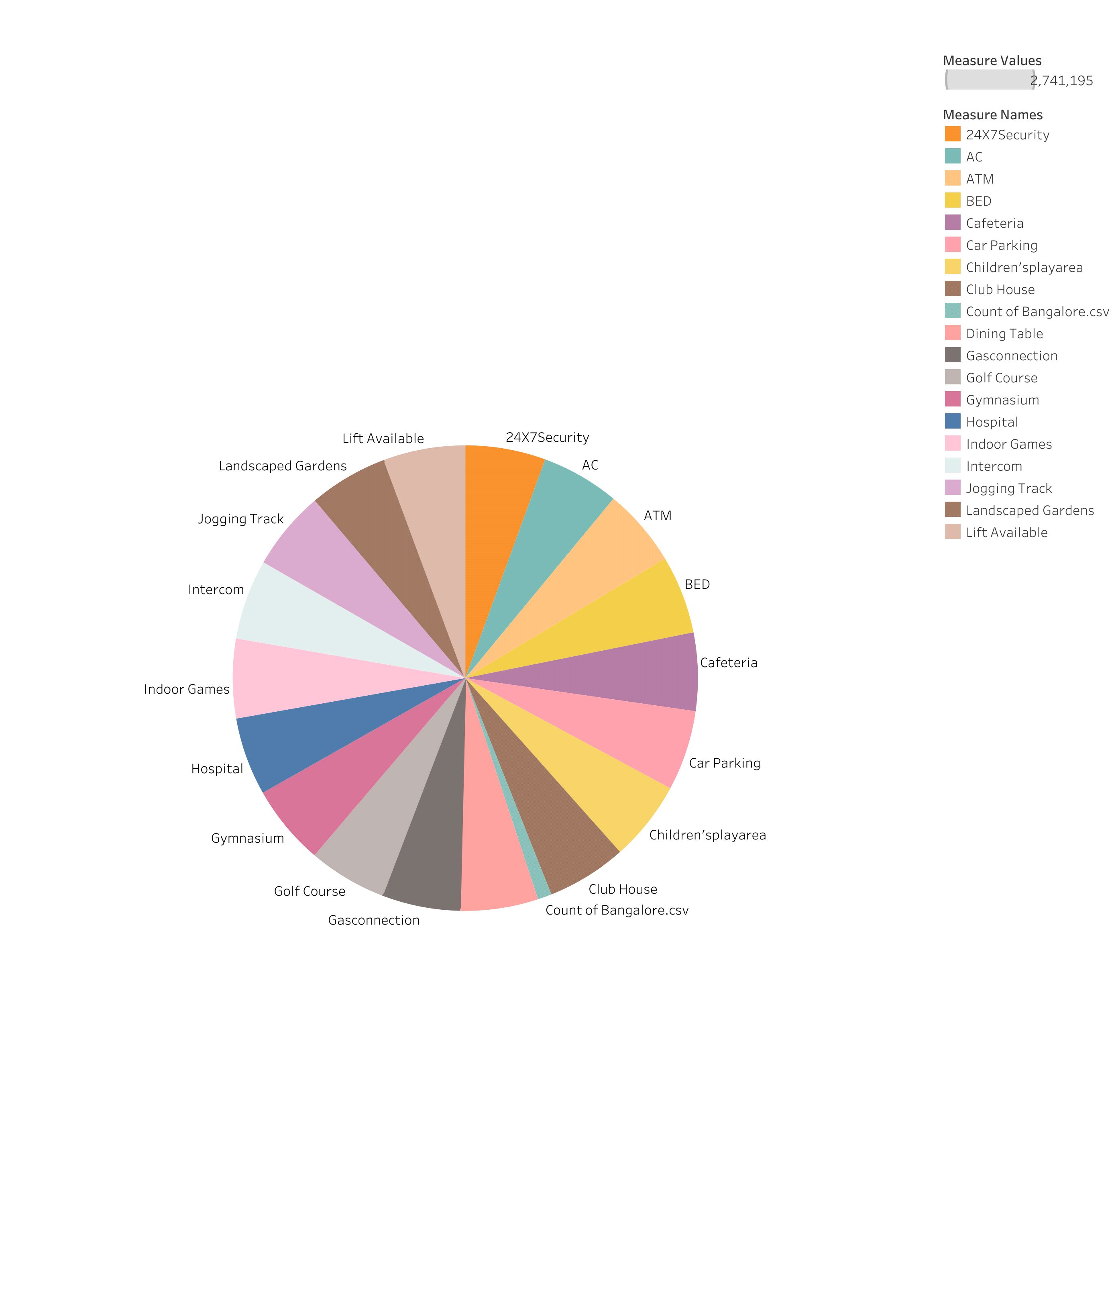

4. ADVANTAGES & DISADVANTAGES

ADVANTAGES

Metropolitan areas are in general more productive than smaller urban agglomerations and rural areas.

DISADVANTAGES

High cost of rent and food. increased competition and societal callousness.

5. APPLICATION

Urbanisation is growing faster and faster that became barriers for balance, quitable and inclusive devlopment.

6. CONCLUSION

The amount of population, economic activities, mobility, activities of the population, and the structure of the region.

7. FUTURE SCOPE

Through natural growth, urban migration, and recategorization of what constitutes a "city", India expects to add 416 million people to its citiess by 2050.